Week 2 - Technical Labs

Journal entries

# All-student prompts

All students should reflect on and respond to the following prompt(s):

| ***Prompt 3: How has your classroom experiences prepared you for the internship? What do you wish you had learned prior to the internship?*** |
| --- |
| I had the opportunity to take technical/ STEM classes at my high school and there are networking opportunities provided by the clubs and associations I am in. My teachers allow for a lot of personal exploration of our interests so I’ve been able to create coding projects even in my english classes. Being completely transparent, there is nothing I really wish I had learned prior to this internship because this opportunity covers the foundations/ beginning of everything so I never felt lost or left behind in any way. |

# Export + contribute your reflection

1. Once you’ve filled out the above prompts, export this doc as a PDF. Note: make sure you rename the file to be in the format [Firstname Lastname] Week 2 Journal Entries  
   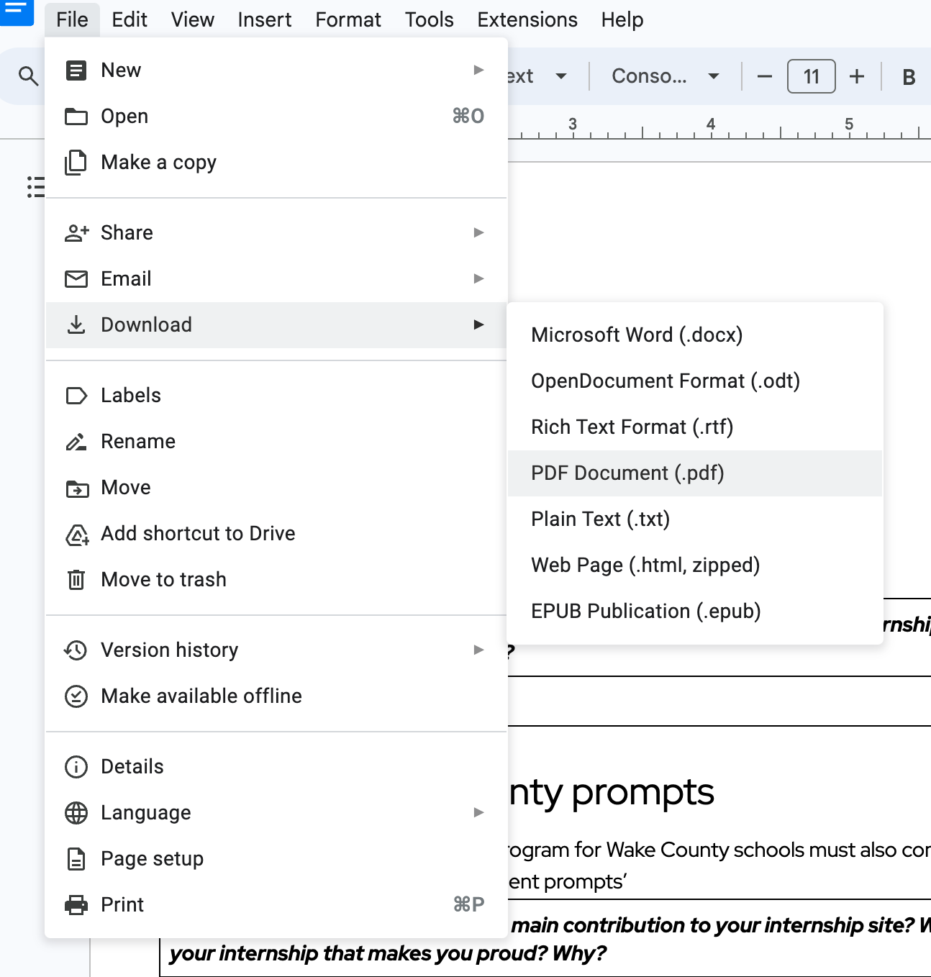
2. Now that you have a PDF of this week’s reflections saved locally to your laptop, you should contribute the PDF to your personal GitHub dropbox area in our [shared repo](https://github.com/RH-HS-Interns-2024/RH-HS-Interns-2024.github.io/tree/main/interns).